What Is Money
A first book about U.S. coins and bills and learning to save
State and Nation
For elementary school readers
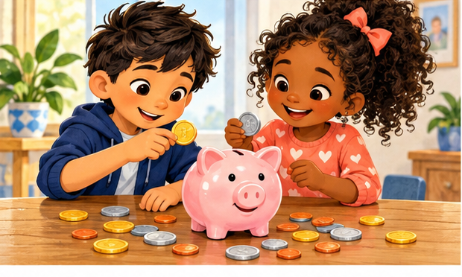
Count • Discover • Save

Hello Money Explorers
A penny jingles. A dollar bill rustles. A savings account keeps track of money for later. Each one has a story!
In this book, you will learn how much U.S. coins and bills are worth, meet the people pictured on them, and discover why saving matters.
You can read on your own or with a grown-up. Younger readers can start with the pictures and counting games. Older readers can explore the history and bank words.
Bring your curiosity. You do not need your own money to practice. Paper circles and pretend dollars work, too.

Before you read: What do you already know about money?

Money Helps Us Trade
Money is something people use to pay for goods and services. Goods are things, like apples or pencils. Services are things people do, like giving a haircut or repairing a bicycle.
Long ago, people sometimes traded one thing for another. This is called barter. But what if you have apples and the person with pencils does not want apples? Money makes trading easier.
In the United States, we count money in dollars and cents. One dollar equals 100 cents. We write one dollar as $1.00.
Money can be cash in your hand or an amount recorded in an account. A bank card or phone payment uses money from an account or borrowed money. It is not free money.
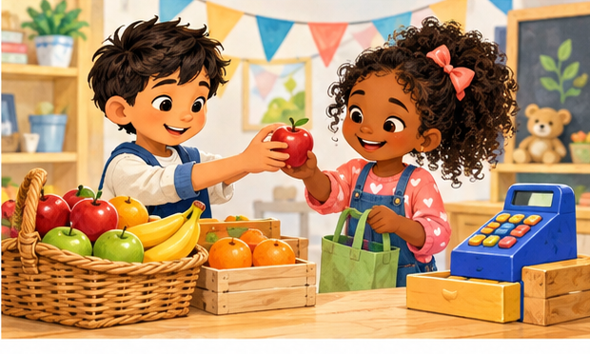
Talk about it: Name one good and one service.

Meet the Coins
Coins are metal money. A coin has a front, a back, and an edge. People often call the front heads and the back tails.
The amount a coin is worth is called its value. A bigger coin is not always worth more. A little dime is worth more than a larger nickel!
These are the six coin values to know. Some are easier to find than others.
Coin | Value | Makes $1
Penny | 1 cent | 100 pennies
Nickel | 5 cents | 20 nickels
Dime | 10 cents | 10 dimes
Quarter | 25 cents | 4 quarters
Half dollar | 50 cents | 2 half dollars
Dollar coin | 100 cents | 1 dollar coin

Look closely: Find the date and the words naming the value on a real coin with a grown-up.

The Penny
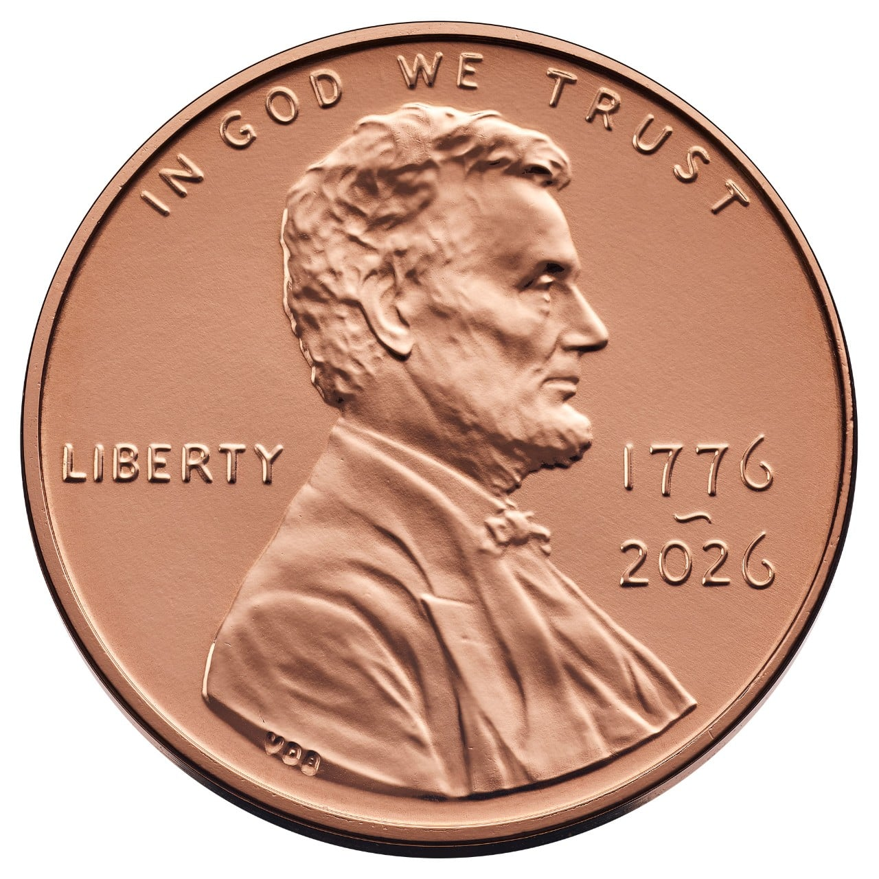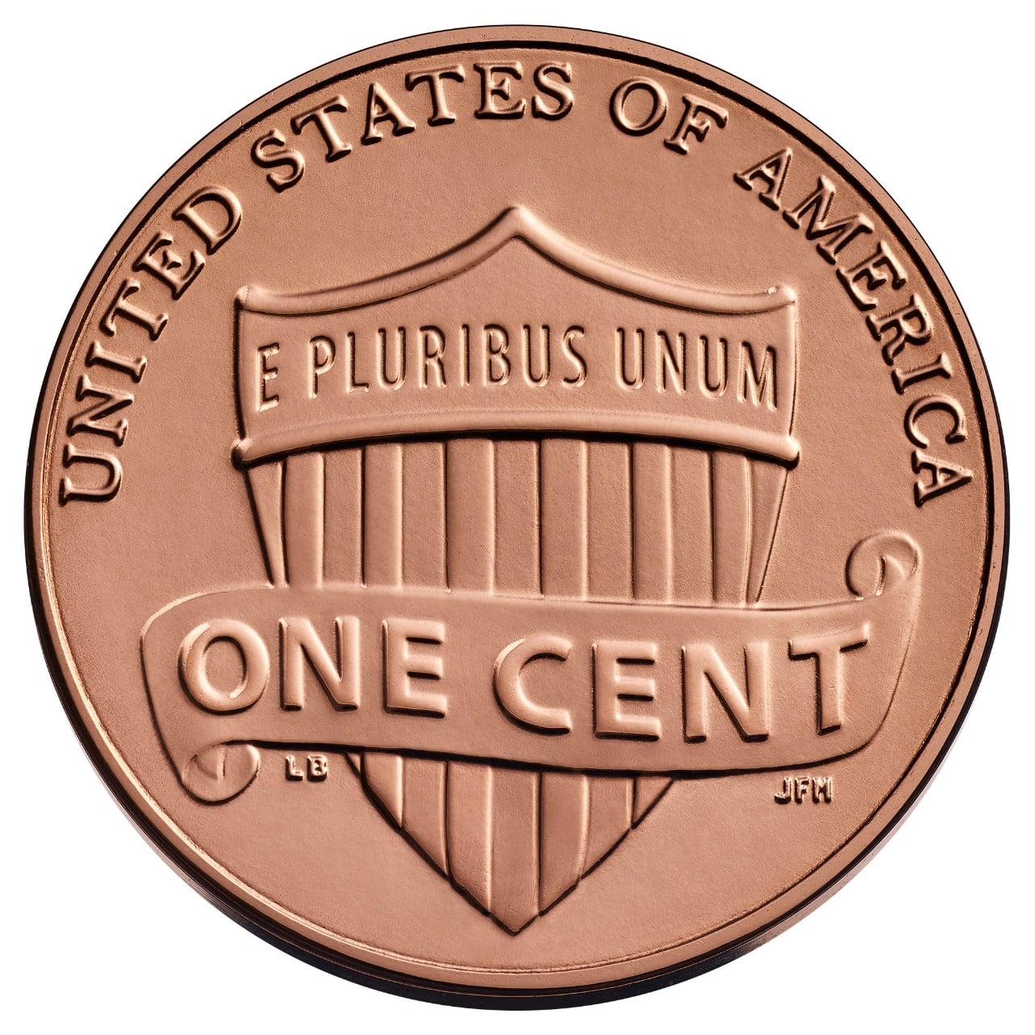
Front and back of a 2026 collector penny. Value 1 cent.
A penny is worth 1 cent. It is usually copper-colored, like a warm reddish brown. One hundred pennies equal one dollar.
Who is on it? Abraham Lincoln, the 16th president of the United States.
Why Lincoln? The Lincoln penny began in 1909 to celebrate 100 years since his birth. It honors a leader who helped keep the country together during the Civil War and worked to end slavery.
Many pennies have a shield on the back. Others have the Lincoln Memorial or older designs.
Penny update: The U.S. Mint stopped making pennies for everyday circulation in November 2025. Existing pennies still count as money and are still worth 1 cent each.
Count it: 5 pennies are worth how many cents?

The Nickel
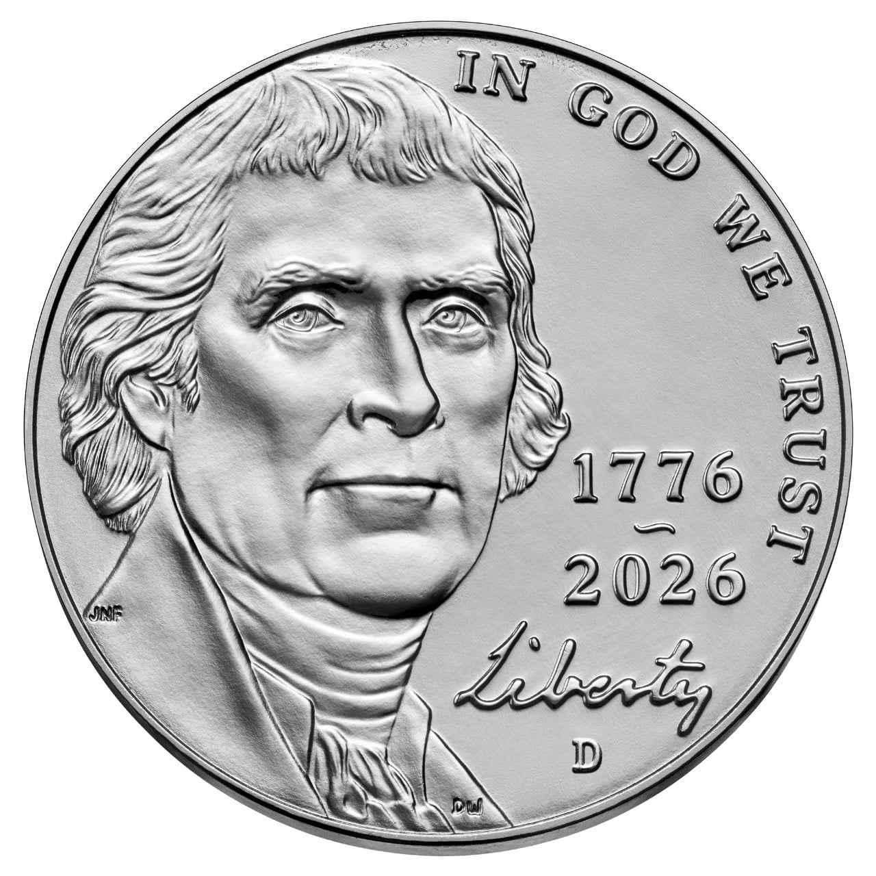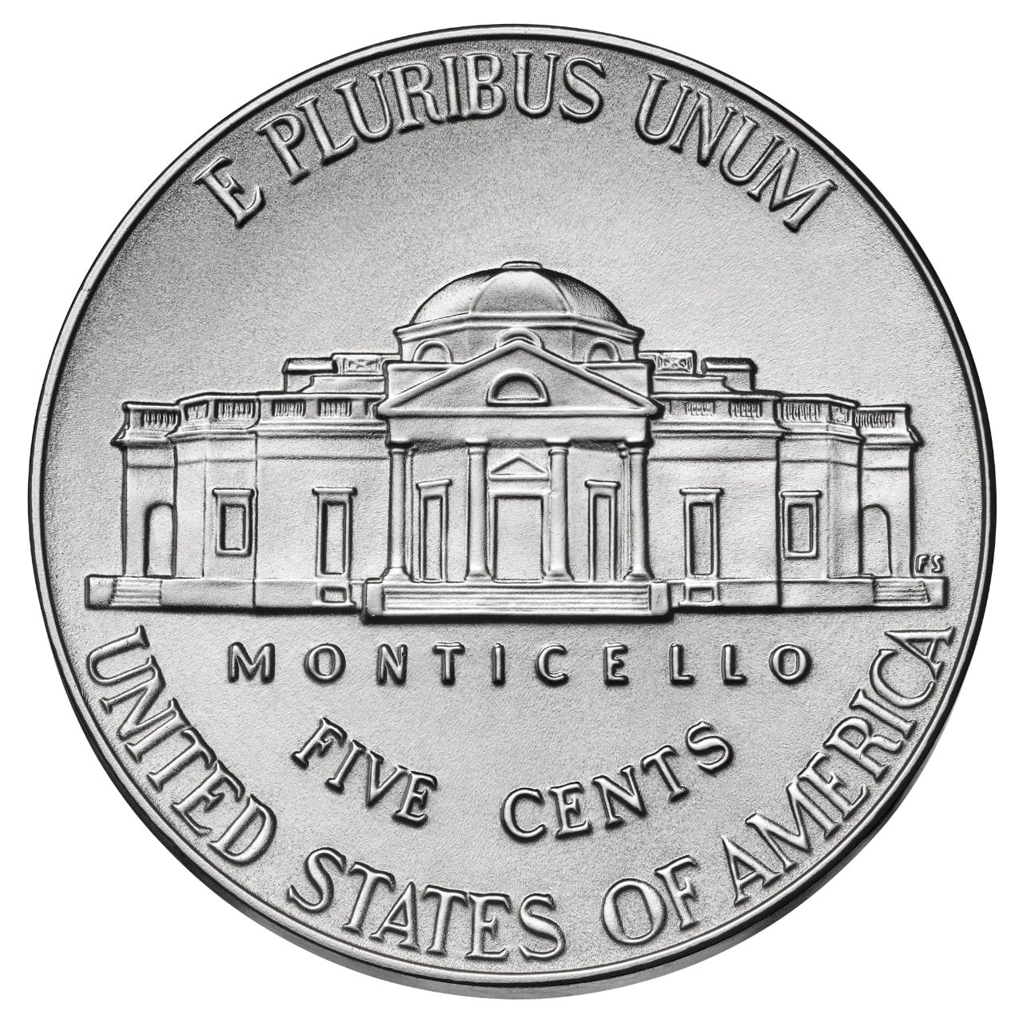
Front and back of a 2026 nickel. Value 5 cents.
A nickel is worth 5 cents. It is silver-colored, but that does not mean it is made of silver. Five pennies have the same value as one nickel.
Who is on it? Thomas Jefferson, the third president.
Why Jefferson? The nickel honors a president and a founder of the country who wrote the main draft of the Declaration of Independence. The 1938 design competition required his portrait and a picture of his home.
His home, Monticello, appears on many nickels. Jefferson wrote about liberty, but he also enslaved people. Learning history means looking at both achievements and harmful actions.
Count by fives: 5, 10, 15, 20. How many nickels make 20 cents?

The Dime
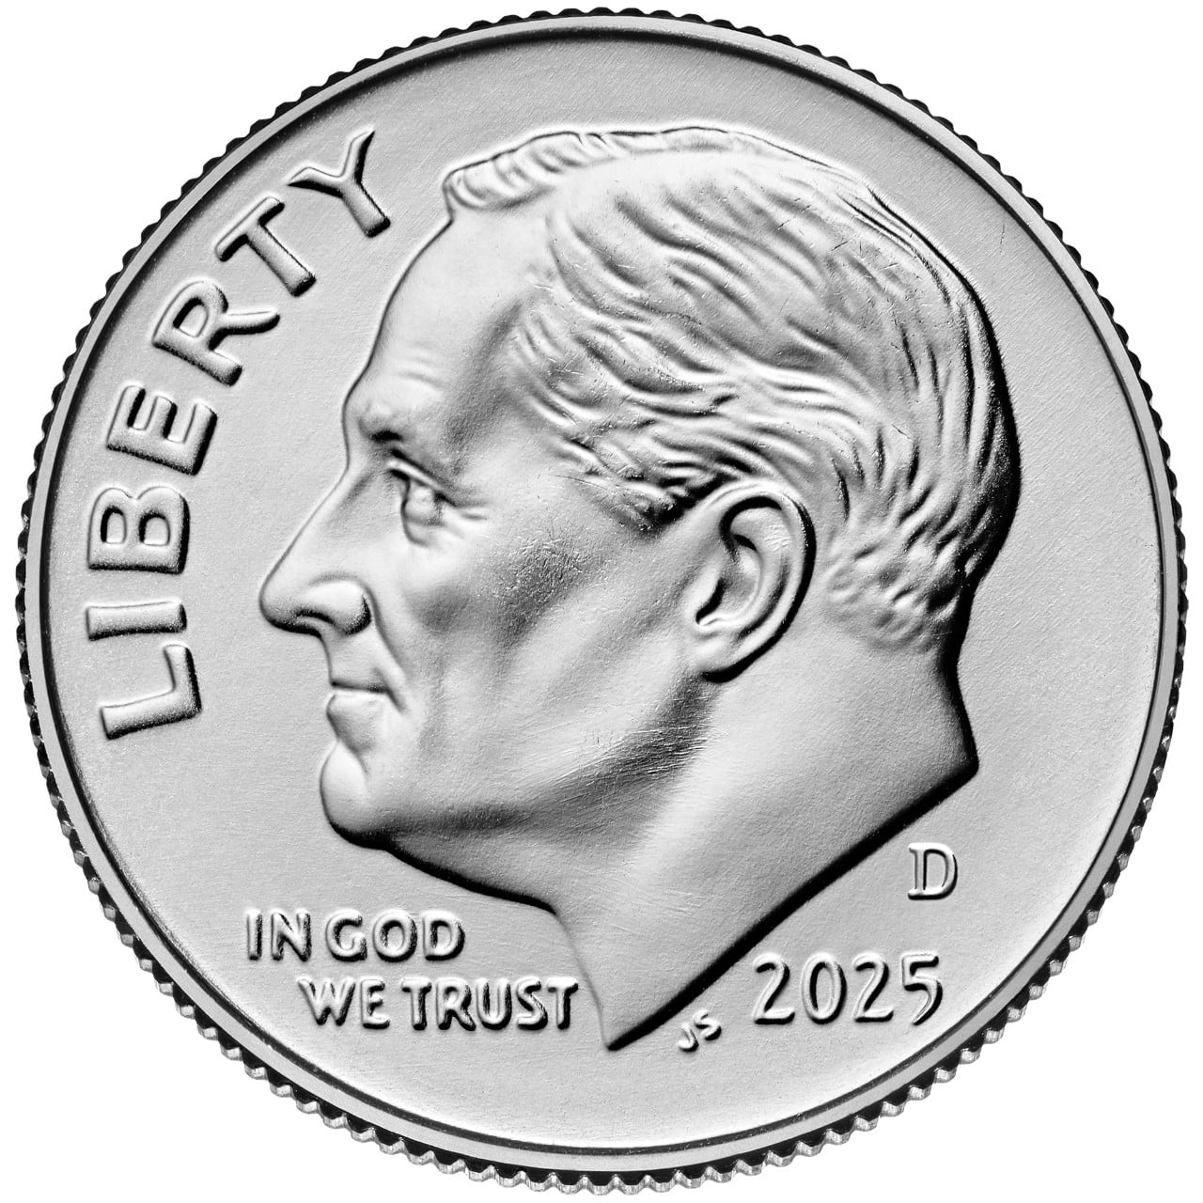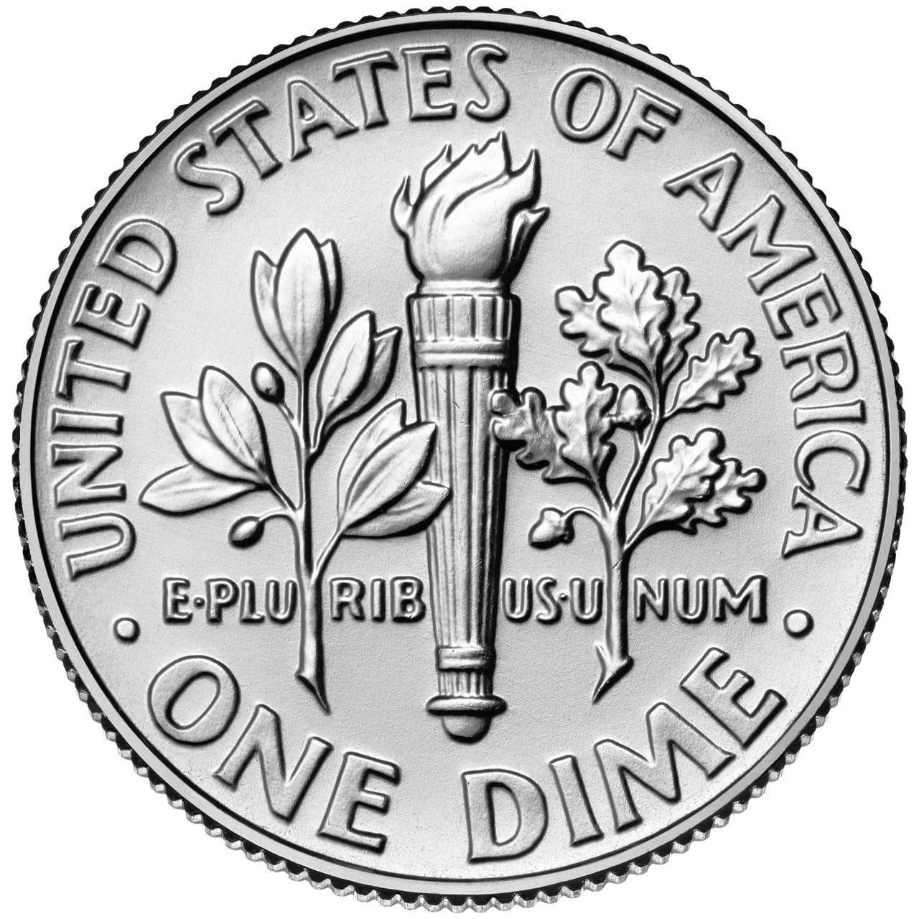
Front and back of a 2025 Roosevelt dime. Value 10 cents.
A dime is worth 10 cents. Two nickels equal one dime. Ten dimes equal one dollar.
Who is usually on it? Franklin D. Roosevelt, the 32nd president. His portrait first appeared on the dime in 1946, after he died.
Why Roosevelt? He supported the March of Dimes, which raised money to fight polio, a serious disease. The dime was a fitting way to remember that work. He also led the country during the Great Depression and much of World War II.
The familiar back shows a torch and branches. In 2026, a special dime shows Liberty instead of Roosevelt. It still has the same 10-cent value.
Think it through: Which is worth more, 1 dime or 1 nickel?

The Quarter
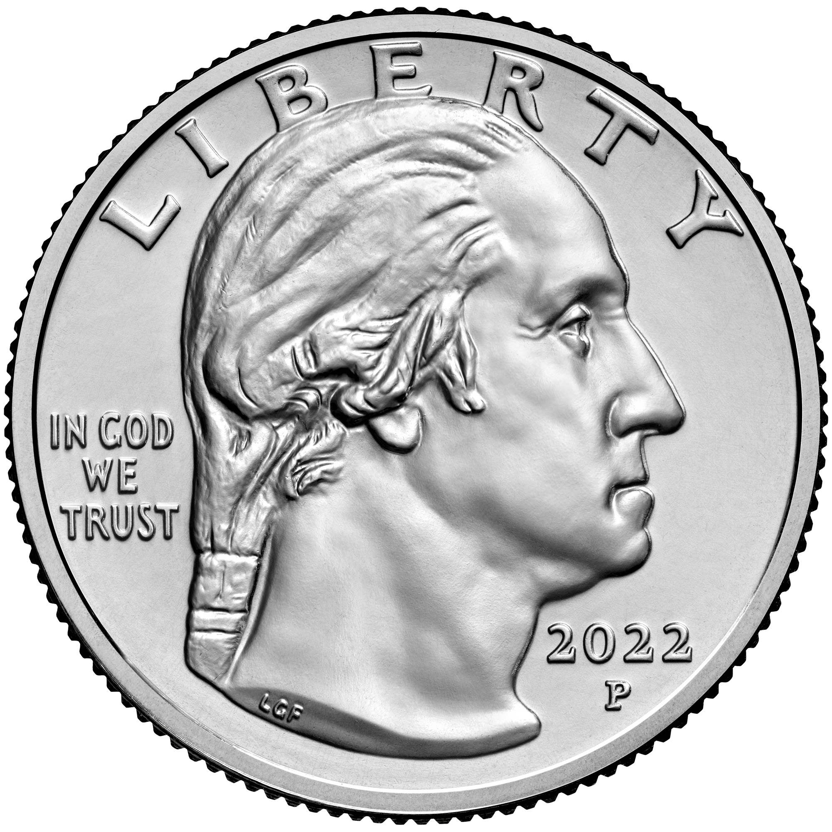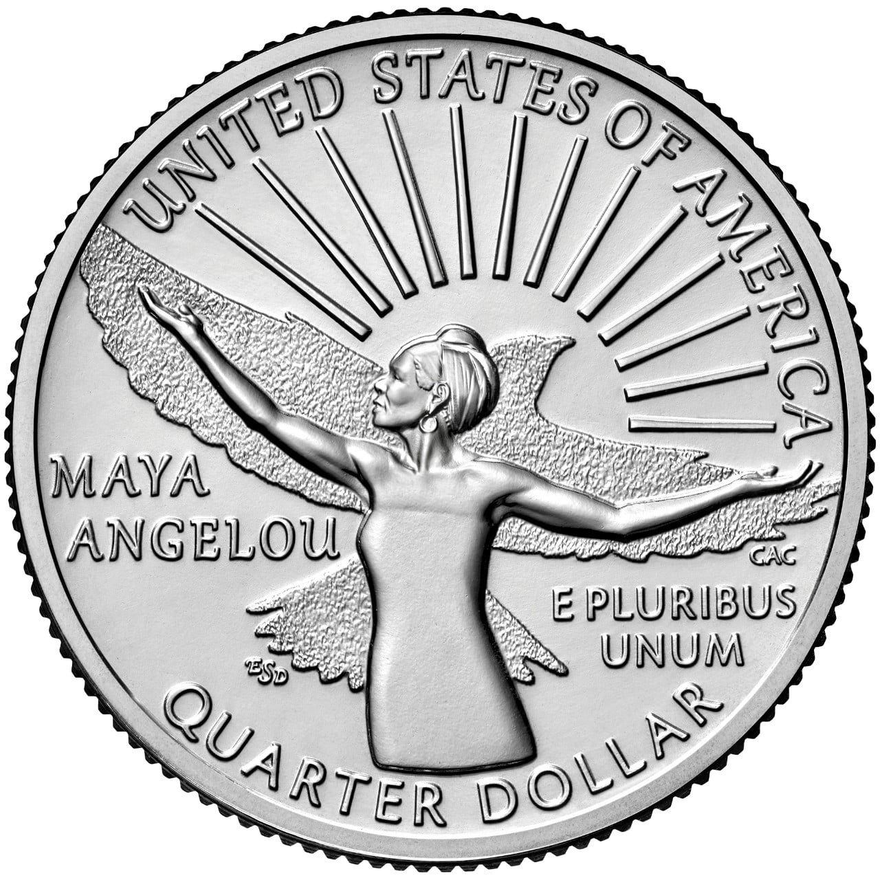
2022 quarter: Washington on the front; writer Maya Angelou honored on the back. Value 25 cents.
A quarter is worth 25 cents. A quarter means one of four equal parts. Four quarters make one dollar.
Who is usually on the front? George Washington, the first president. His portrait began appearing on quarters in 1932.
Why Washington? That year marked 200 years since his birth. The design honored his leadership in the American Revolution and his service as the first president.
The backs of quarters tell many stories. You might see a state, a national park, or a woman honored for her achievements. Special 2026 quarters tell stories about American history, and some have different front designs.
Count by quarters: 25, 50, 75, 100. How many quarters make 75 cents?

The Half Dollar
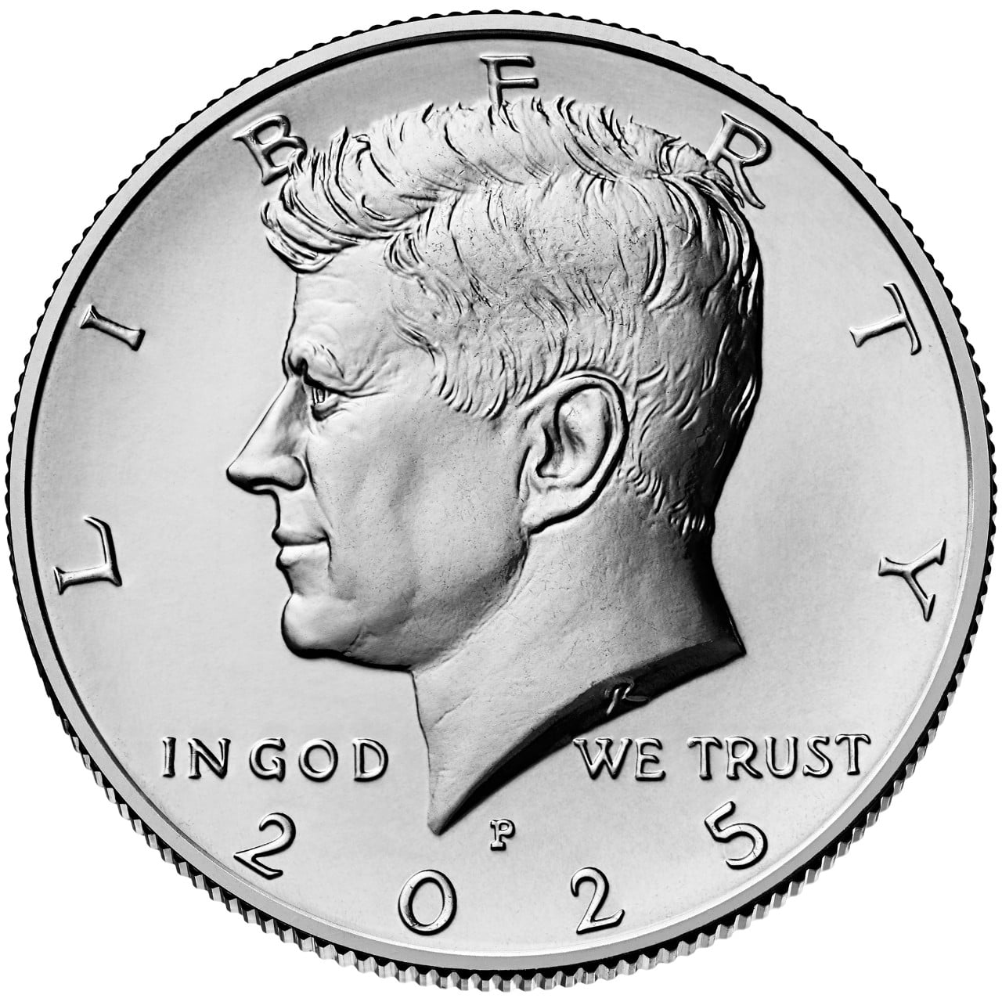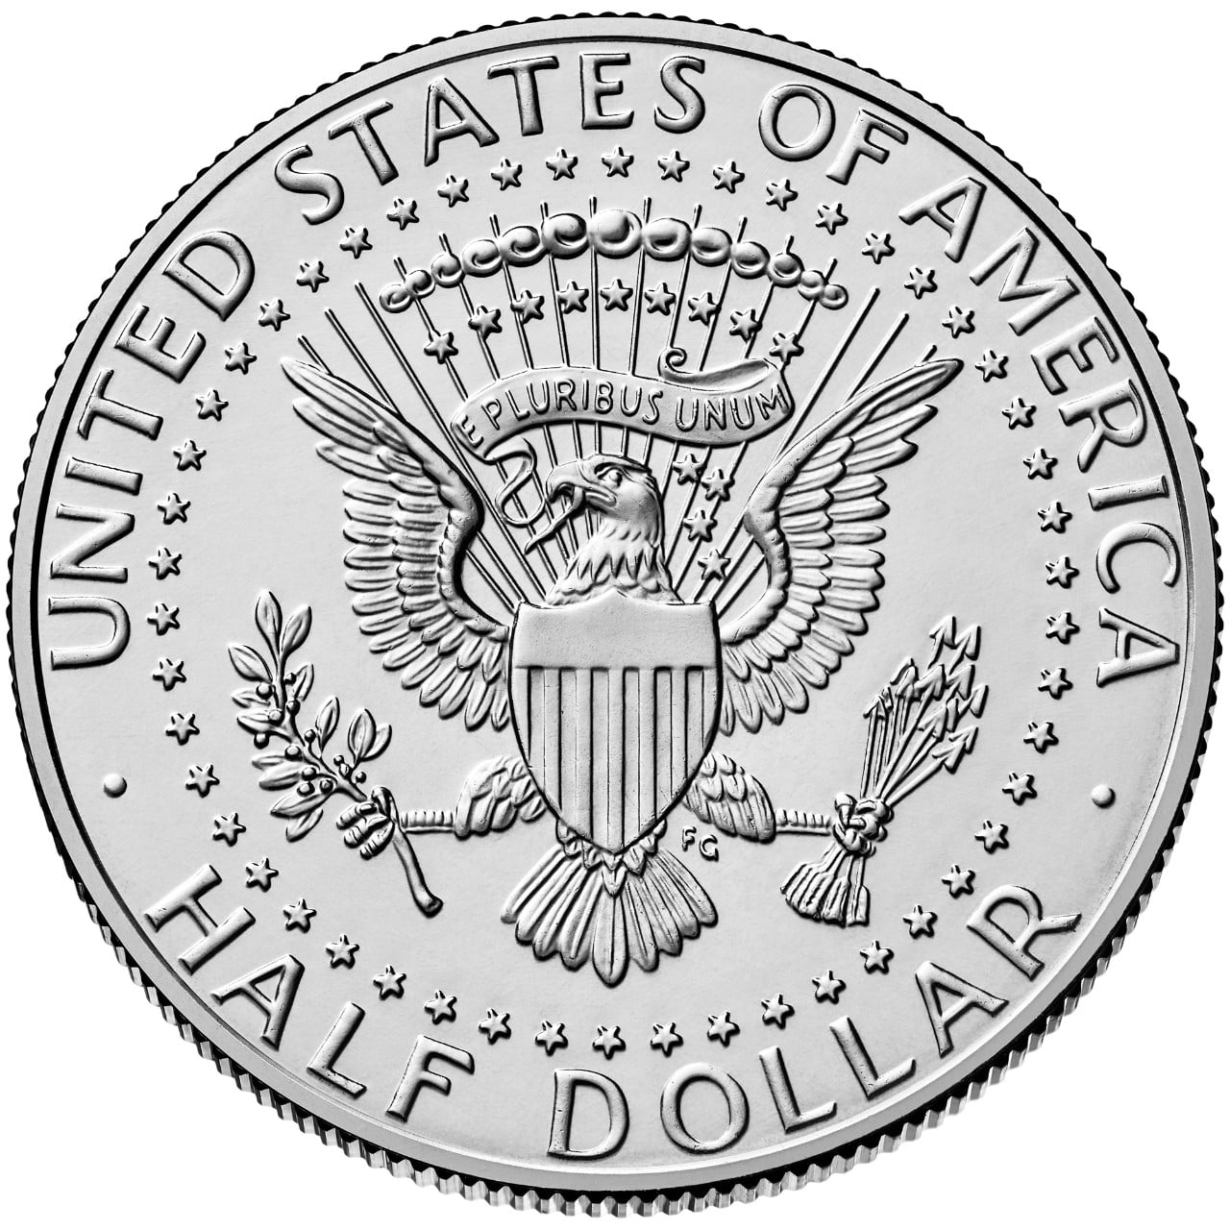
Front and back of a 2025 Kennedy half dollar. Value 50 cents.
A half dollar is worth 50 cents. Two quarters equal one half dollar. Two half dollars equal one dollar.
Who is usually on it? John F. Kennedy, the 35th president. The Kennedy half dollar first appeared in 1964.
Why Kennedy? The coin was created to remember him after he was killed in 1963. It honors his life and his service as president.
The usual back has an eagle based on the presidential seal. A special 2026 half dollar shows the Statue of Liberty on the front instead.
Half dollars are real money, even though you may not see them often in change.
Make a match: 1 half dollar has the same value as how many dimes?

The Dollar Coin
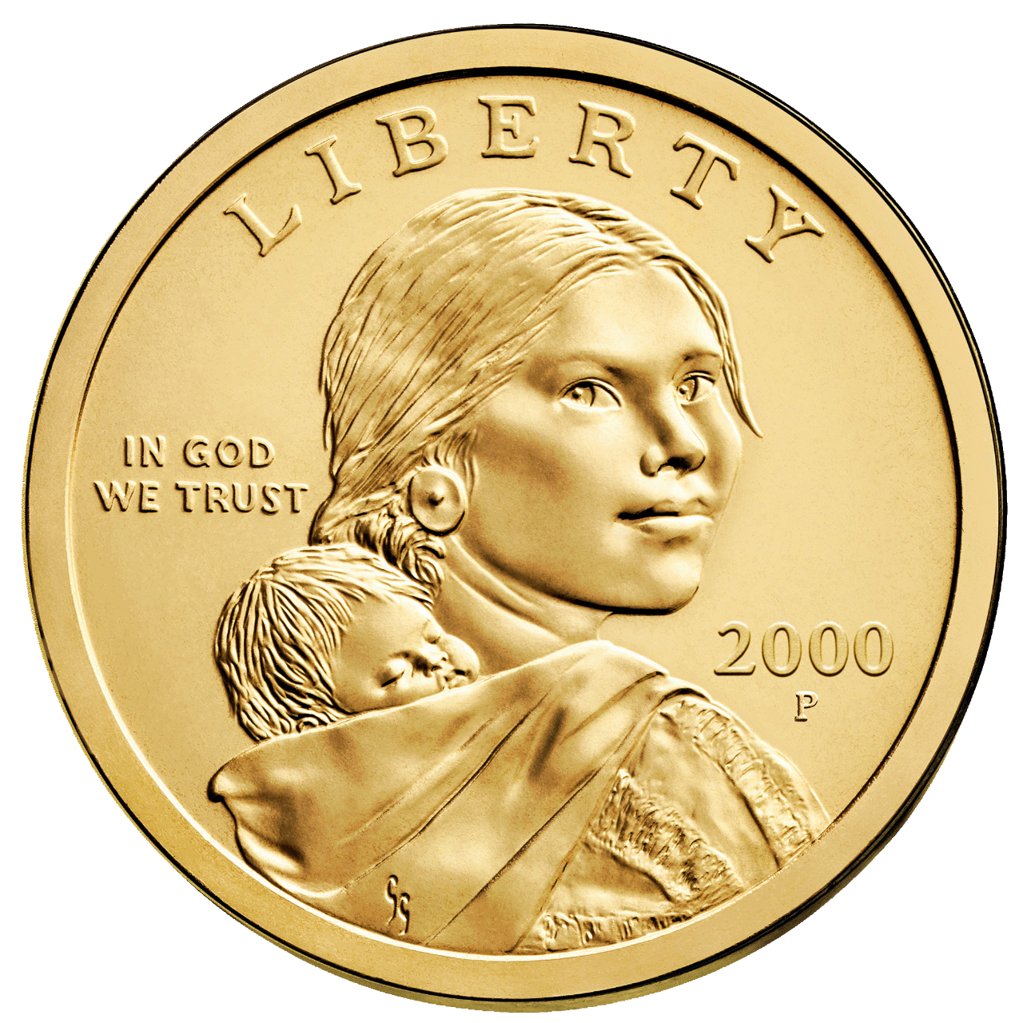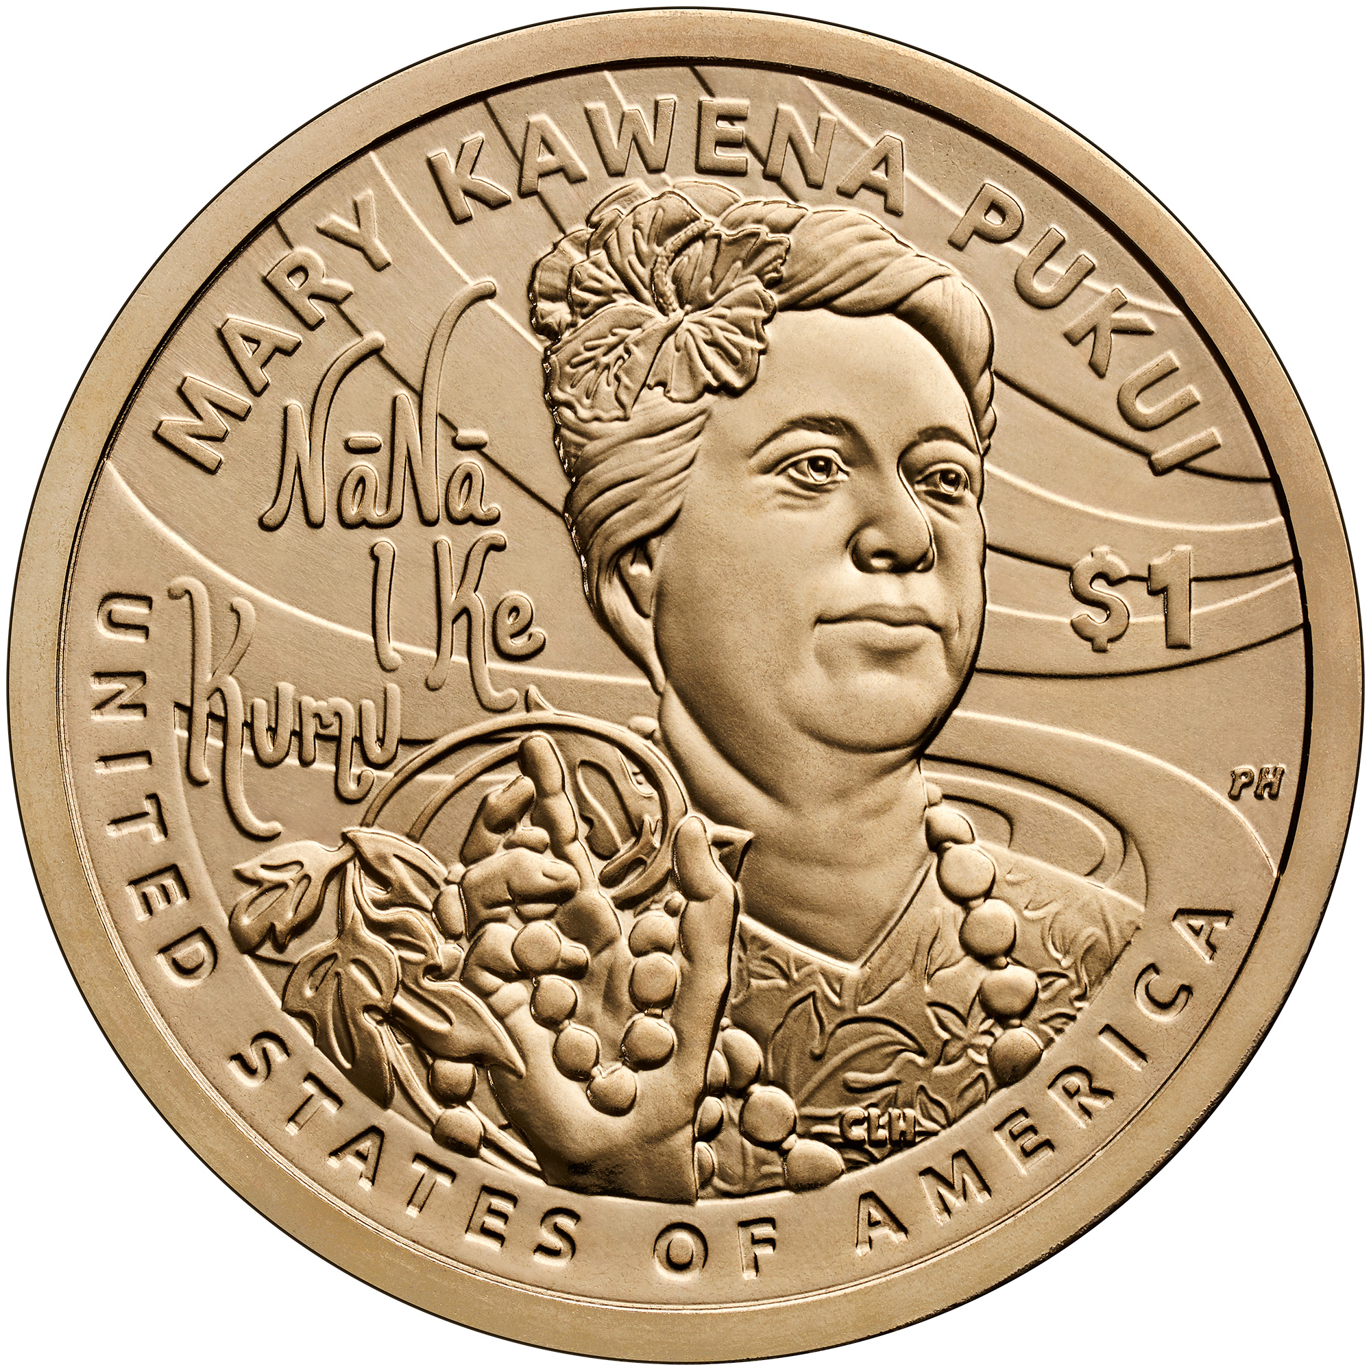
Dollar examples: Sacagawea front from 2000; 2025 back honoring Mary Kawena Pukui for preserving Hawaiian language and culture. Each coin is worth $1.
A dollar coin is worth $1.00, or 100 cents. It has the same spending value as a one-dollar bill.
Who might you see? Sacagawea and her baby appear on Native American dollar coins. She was a Shoshone woman who helped the Lewis and Clark expedition communicate and travel. The design honors her important help.
Older dollar coins feature Susan B. Anthony, who worked for women's voting rights, or President Dwight D. Eisenhower, honored after his death. Other dollars honor presidents.
American Innovation dollars show the Statue of Liberty and celebrate inventions and discoveries. Liberty is a symbol of freedom, not a president.
Many recent dollar coins look golden but are not solid gold. Most new dollar coins are made for collectors rather than everyday change.
Same value: 1 dollar coin equals how many quarters?

Coins Can Change Their Clothes
Imagine a coin wearing a different picture, like a new shirt. Its design can change while its value stays the same.
In 2026, the United States celebrates 250 years since the Declaration of Independence. Special coin designs help tell that story.
The 2026 dime shows a figure called Liberty. The special half dollar shows the Statue of Liberty. Five quarter designs highlight the Mayflower Compact, the Revolutionary War, the Declaration of Independence, the Constitution, and the Gettysburg Address.
Look for both the year and the value. A 2026 dime is still worth 10 cents. A quarter with a different picture is still worth 25 cents.
Older designs can stay in use alongside newer ones.
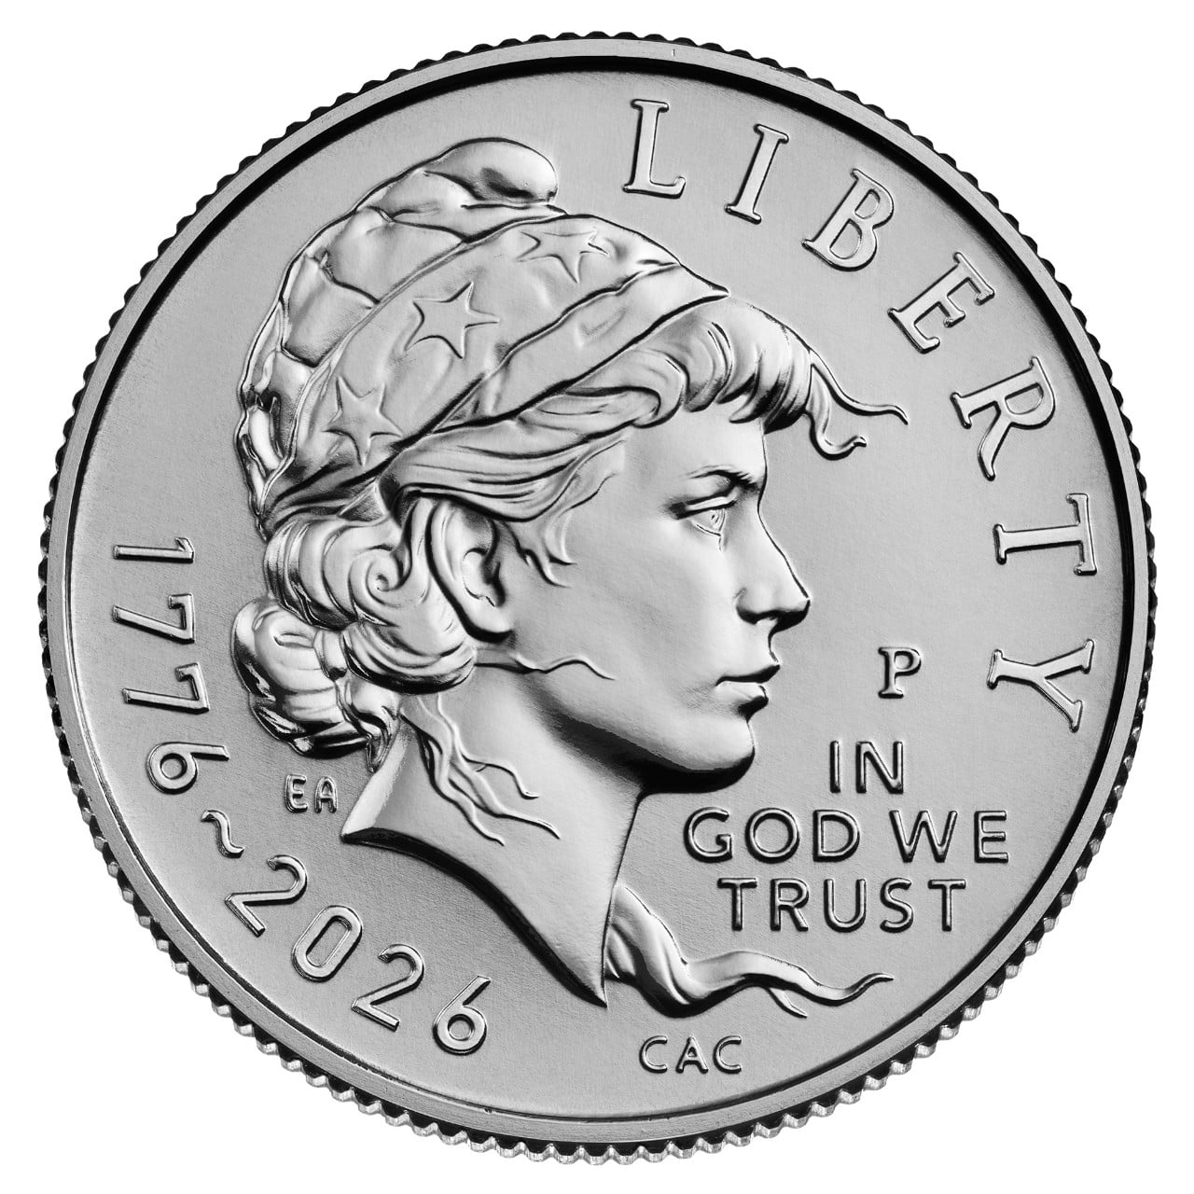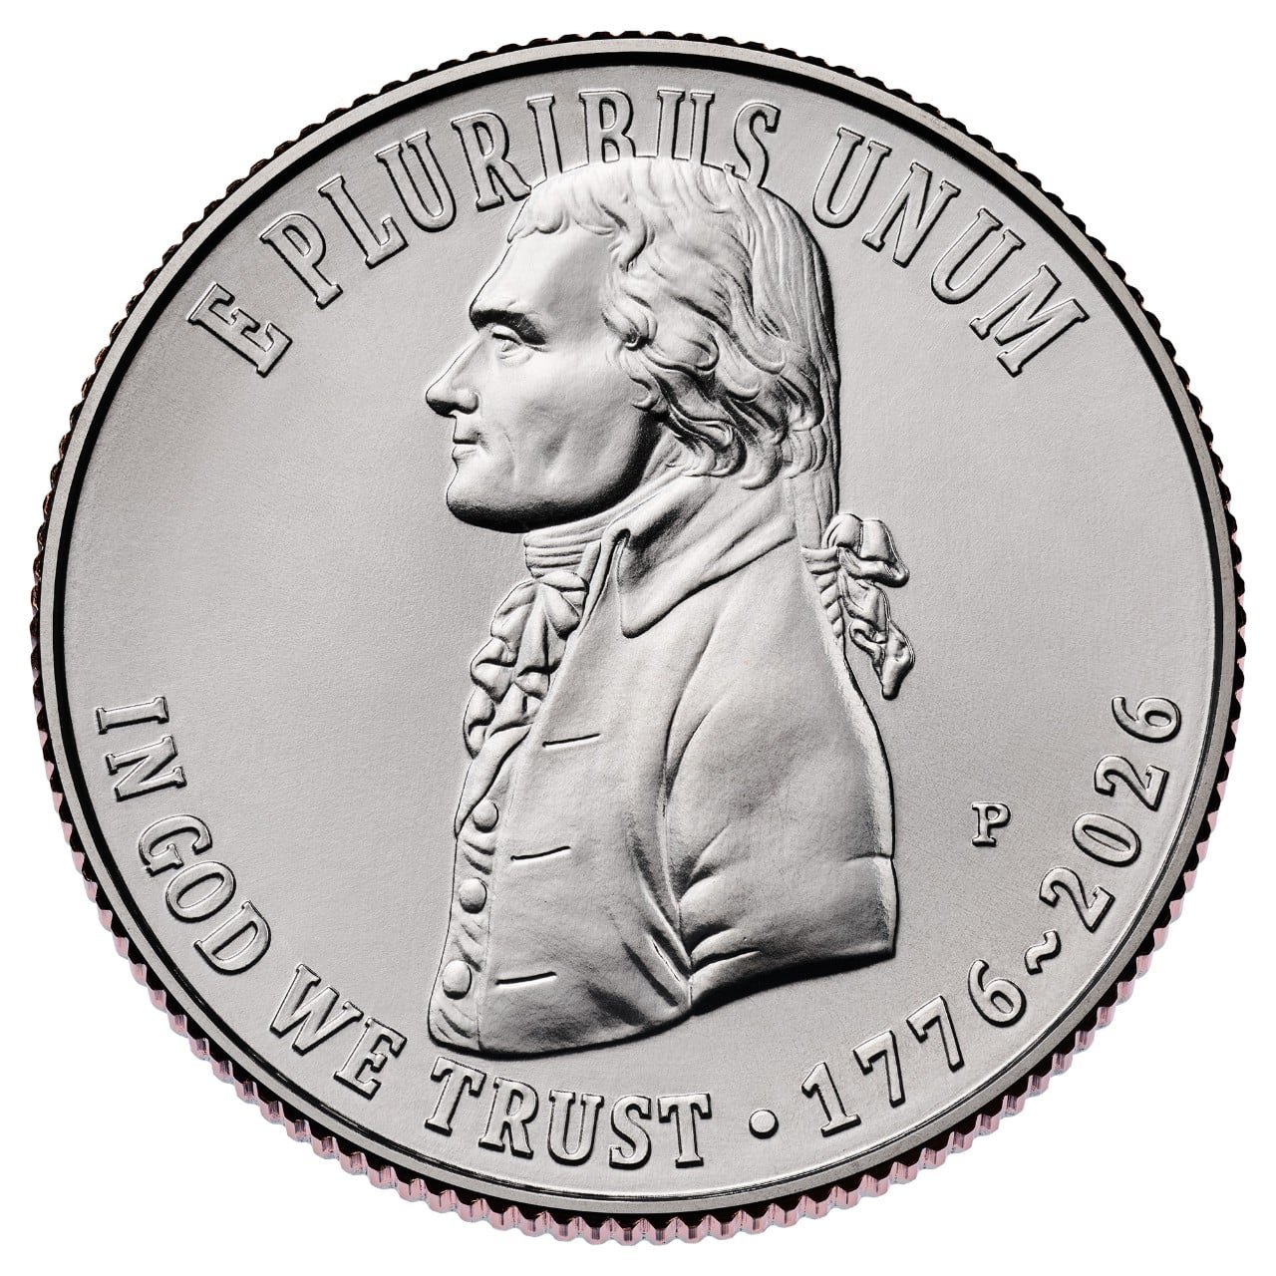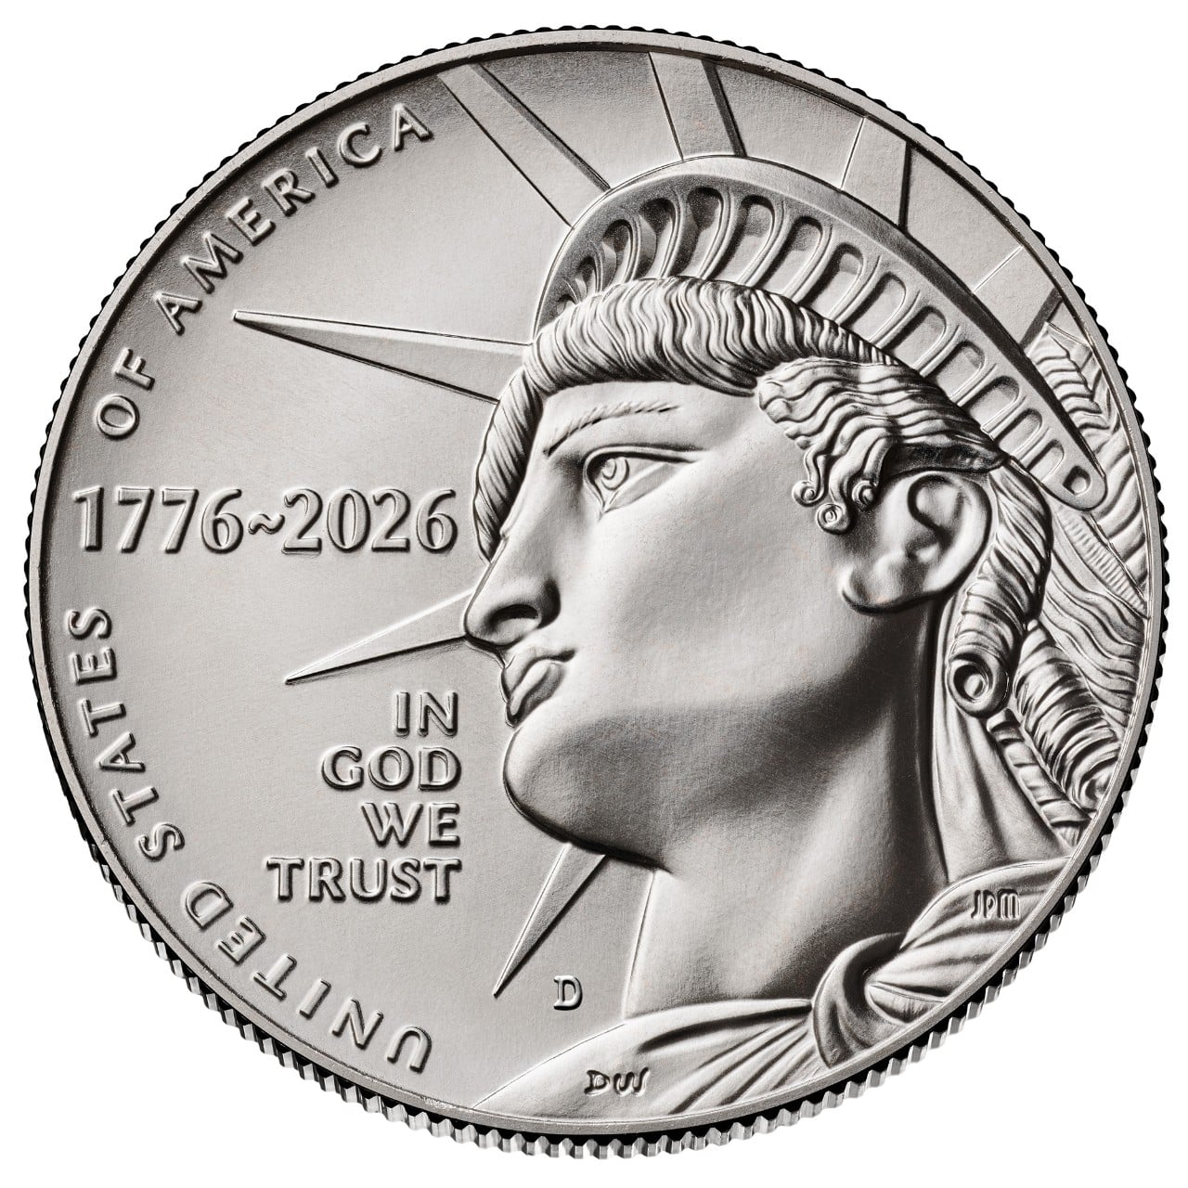
2026 designs: Liberty dime, Declaration of Independence quarter, and Statue of Liberty half dollar. Coin pictures are enlarged.
Design challenge: Draw a pretend coin that celebrates something kind in your community. Write its value.

Meet the Bills
A bill is also called a note. Bills are a type of cash, just like coins. Their values are called denominations.
The seven U.S. bill values issued today are $1, $2, $5, $10, $20, $50, and $100. Read the numbers carefully. All seven have the same physical size!
Most current bills show a president on the front. Two show famous Americans who were never president.
Bill | Person on the front
$1 | George Washington
$2 | Thomas Jefferson
$5 | Abraham Lincoln
$10 | Alexander Hamilton
$20 | Andrew Jackson
$50 | Ulysses S. Grant
$100 | Benjamin Franklin

Find the pair: Which two people in this list were never president? Read on to find out.

The One Dollar Bill
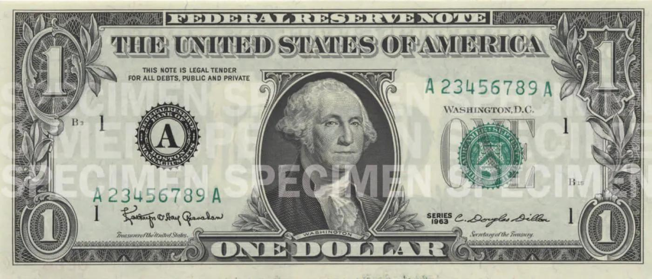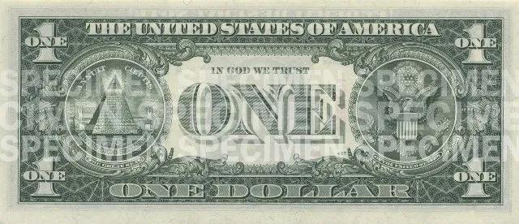
Front and back of the $1 bill. Images reduced for learning.
Value: $1.00. One one-dollar bill equals four quarters or ten dimes.
Who is on it? George Washington, the first president.
Why Washington? His portrait honors his role in founding the country. He led the American army in the Revolutionary War and helped the new nation begin governing itself.
What is on the back? The Great Seal of the United States. Its two sides include an eagle and an unfinished pyramid.
Look for the numeral 1 and the words ONE DOLLAR. The portrait is a clue, but the printed value tells you how much the bill is worth.
Make a dollar: Name two different groups of coins worth $1.

The Two Dollar Bill
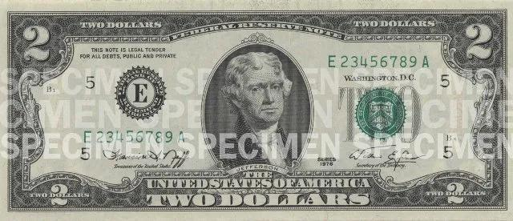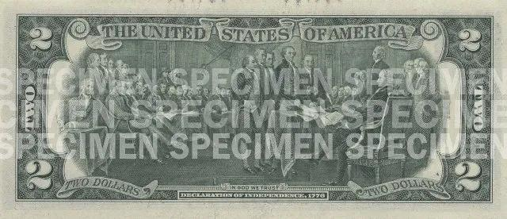
Front and back of the $2 bill. Images reduced for learning.
Value: $2.00. A two-dollar bill equals two one-dollar bills.
Who is on it? Thomas Jefferson, the third president.
Why Jefferson? He is remembered as a founder of the United States and the main writer of the Declaration of Independence. His portrait recognizes his role in the country's beginnings.
What is on the back? A picture based on a painting about presenting the Declaration of Independence to Congress.
A two-dollar bill is real money. You may see it less often, but being unusual does not automatically make a bill valuable to collectors.
Jefferson's words about equality and his enslavement of people remind us that history includes contradictions.
Count it: How many quarters have the same value as $2?

The Five Dollar Bill
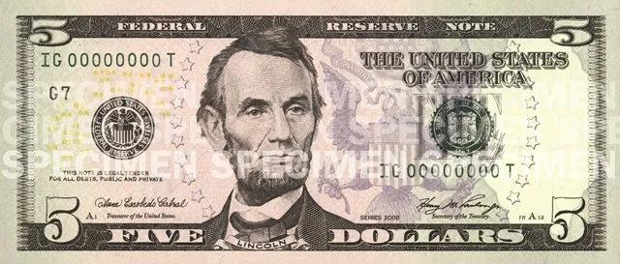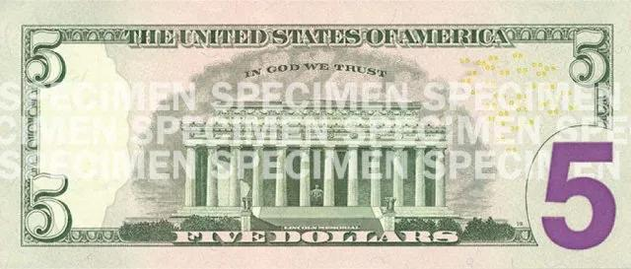
Front and back of the $5 bill. Images reduced for learning.
Value: $5.00. A five-dollar bill equals five one-dollar bills.
Who is on it? Abraham Lincoln, the 16th president.
Why Lincoln? He is remembered for leading the country during the Civil War, preserving the Union, and helping bring an end to slavery. His portrait honors that place in American history.
What is on the back? The Lincoln Memorial in Washington, D.C.
A building on a bill can help us remember a person's story. The Lincoln Memorial is a place where people reflect on Lincoln's life and the meaning of freedom.
Pretend shop: A book costs $3. You pay $5. How much change should you receive? Ignore tax for this game.

The Ten Dollar Bill
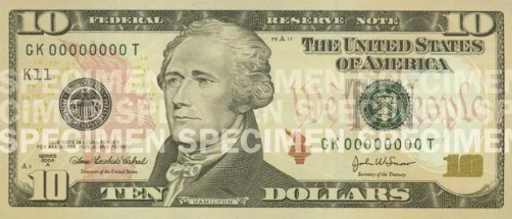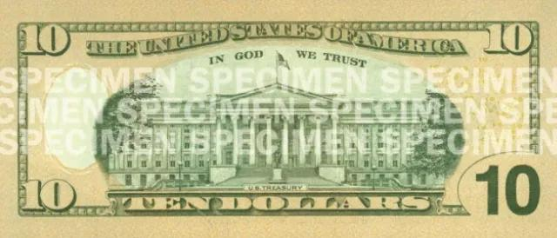
Front and back of the $10 bill. Images reduced for learning.
Value: $10.00. A ten-dollar bill equals two five-dollar bills.
Who is on it? Alexander Hamilton. He was never president!
Why Hamilton? He was the first secretary of the Treasury. That job helps manage the nation's money. He helped build the new country's financial system, making him an important person to remember on money.
What is on the back? The U.S. Treasury building in Washington, D.C.
People can serve a country in many ways. Hamilton's work with government finances shows that the portraits on bills are not only portraits of presidents.
Make a match: 1 ten-dollar bill equals how many two-dollar bills?

The Twenty Dollar Bill
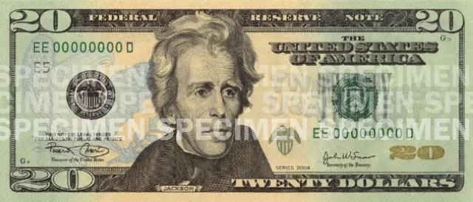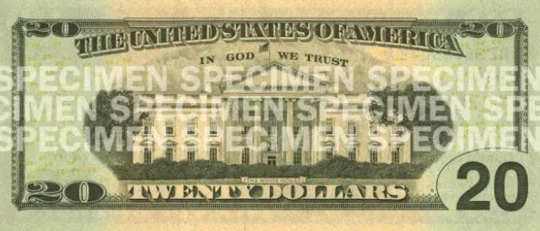
Front and back of the $20 bill. Images reduced for learning.
Value: $20.00. A twenty-dollar bill equals two ten-dollar bills.
Who is on the current bill? Andrew Jackson, the seventh president.
Why Jackson? His portrait reflects an older tradition of featuring well-known presidents in American history. The government has not left a clear record explaining every individual bill portrait choice.
What is on the back? The White House.
A picture on money does not mean every action by that person was good. Jackson supported policies that forced Native American people from their homes. This caused terrible suffering.
We can learn who is on money and ask honest questions about the person's choices.
Count it: How many five-dollar bills equal $20?

The Fifty Dollar Bill
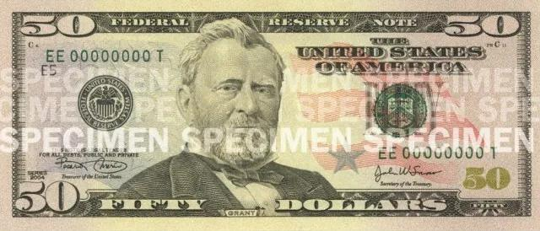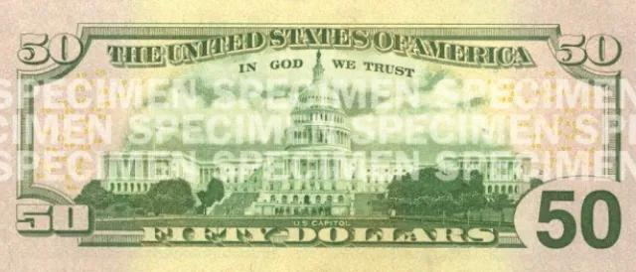
Front and back of the $50 bill. Images reduced for learning.
Value: $50.00. A fifty-dollar bill equals five ten-dollar bills.
Who is on it? Ulysses S. Grant, the 18th president.
Why Grant? His portrait recognizes a major figure in American history. Before becoming president, he led Union armies to victory in the Civil War. As president, he worked to protect the rights of newly freed Black Americans.
What is on the back? The U.S. Capitol, where Congress meets.
Fifty dollars can buy more than five dollars, but the bill itself is the same size. Always check the number.
Money puzzle: $20 + $20 + $10 equals how much?

The One Hundred Dollar Bill
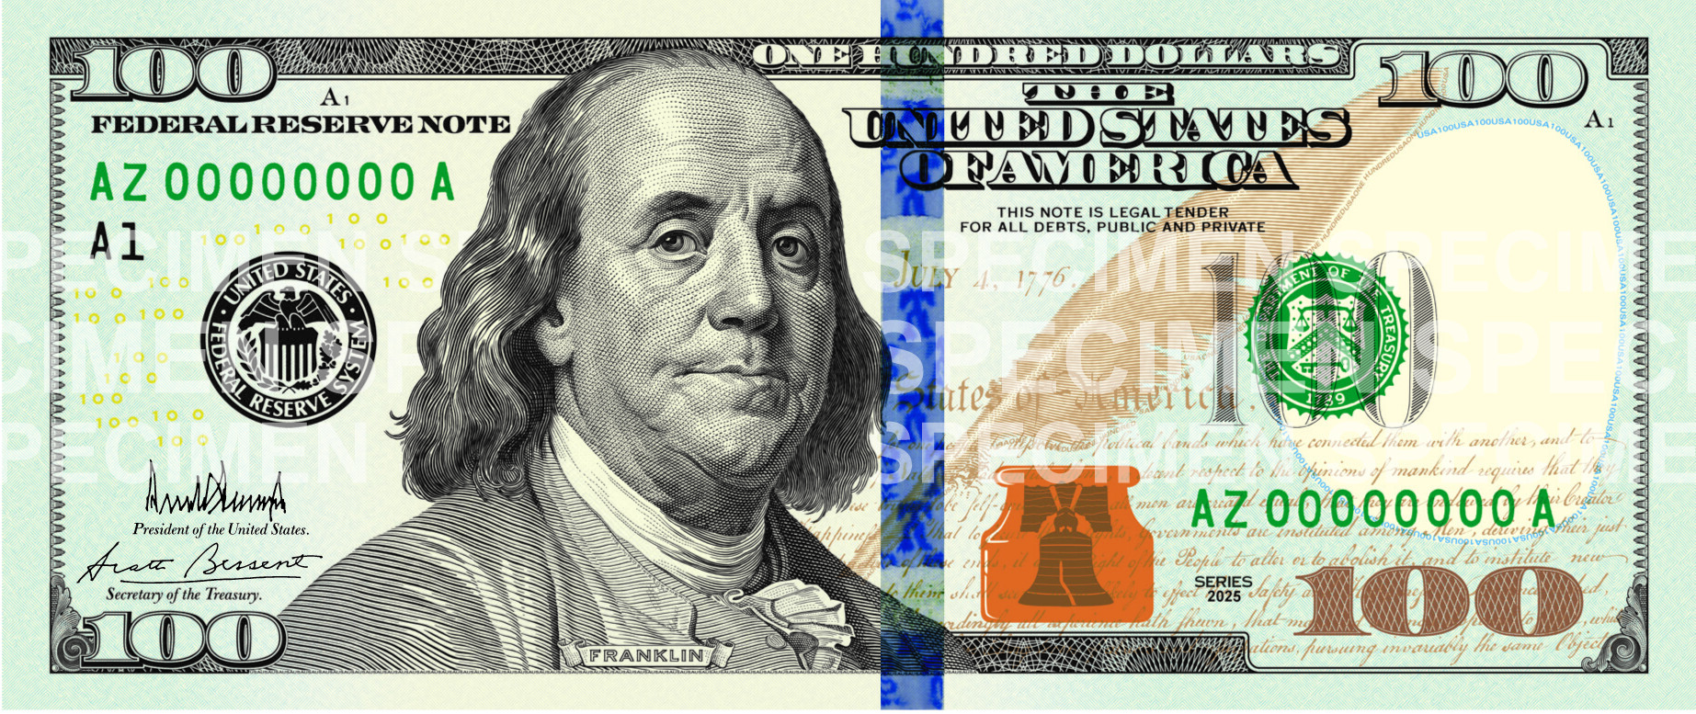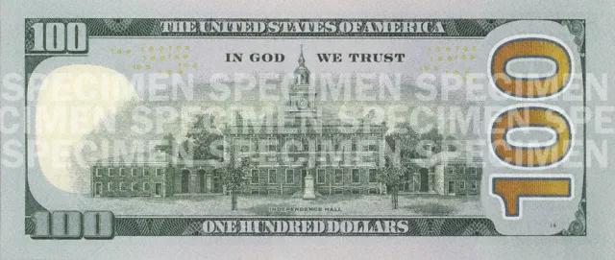
Front and back of the $100 bill. Images reduced for learning.
Value: $100.00. A one-hundred-dollar bill equals ten ten-dollar bills or twenty five-dollar bills.
Who is on it? Benjamin Franklin. He was never president!
Why Franklin? He helped the United States become an independent nation. He was a writer, inventor, diplomat, and a signer of the Declaration of Independence and the Constitution. A diplomat works with people from other countries.
What is on the back? Independence Hall in Philadelphia, where important work on those founding documents took place.
Franklin reminds us that learning, creating, and helping others can all be ways to contribute.
Make a match: How many fifty-dollar bills equal $100?

Money From Long Ago
Today, $100 is the largest bill denomination the Federal Reserve issues. Long ago, the government made larger bills, too.
The familiar later designs pictured these people.
Old bill | Person | Role remembered
$500 | William McKinley | 25th president
$1,000 | Grover Cleveland | 22nd and 24th president
$5,000 | James Madison | 4th president and Constitution leader
$10,000 | Salmon P. Chase | Treasury secretary during the Civil War

History fact: A $100,000 gold certificate showed President Woodrow Wilson. It was used between Federal Reserve Banks, never as ordinary spending money. The U.S. government has never issued a $1 million bill.

Why Put People on Money
Pictures on money can remind people of a country's history. They can honor public service, important events, discoveries, and ideas.
Some coin choices were tied to birthdays or memorials. Lincoln's penny marked 100 years since his birth. Washington's quarter marked 200 years. Kennedy's half dollar remembered him after his death.
Bill portraits recognize people with important roles in the nation's story. The exact reason for every old choice is not fully recorded. Knowing a person's achievements helps us understand the honor without pretending to know every detail of the decision.
History is bigger than the faces on bills. Many women, Native Americans, Black Americans, and other people helped build the country. Some are celebrated on coins.
Being pictured on money does not make someone perfect. We can remember contributions and also learn about harm.
Your choice: Who would you honor on a pretend coin, and why?

How Cash Is Made
The U.S. Mint makes coins. Machines press designs into metal pieces. Workers check the coins before they enter use or go to collectors.
The Bureau of Engraving and Printing makes U.S. bills. The Federal Reserve orders bills and helps distribute them through banks.
Bills feel different from notebook paper because their paper is made from cotton and linen. Special inks and carefully printed designs help people recognize real money.
A country cannot become rich just by printing more bills. People also need useful goods, services, and work. If money grows faster than the things available to buy, prices can rise.
Pretend money is fine for a game. It must stay clearly pretend.
Notice it: With a grown-up, compare the feel of a bill with ordinary paper. Keep both clean and unmarked.

Why Save Money
Saving means keeping some money to use later instead of spending it all now.
A little money saved again and again can help you reach a goal. Your goal might be a book, a game, a gift, or a bicycle helmet.
Saving can also help with surprises. Grown-ups often save for an unexpected repair or another urgent expense. This is sometimes called emergency savings.
Waiting gives you time to decide whether you really want something. You may find that a different goal matters more.
You do not need a big amount to practice. If you do not have money to save, use pretend coins and practice making a plan. Every family's situation is different.
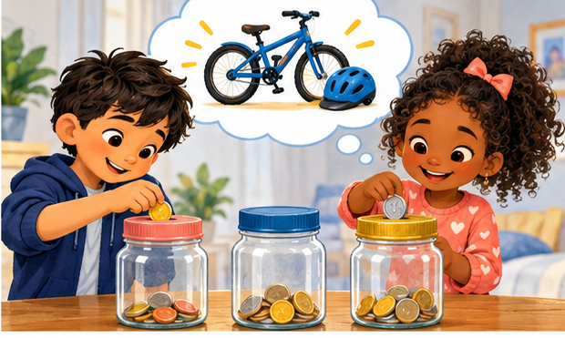
Finish the sentence: I would like to save for ______ because ______.

What Is a Savings Account
A savings account is a place at a bank or credit union to keep money for later. The account records how much money belongs to you.
Putting money in is a deposit. Taking money out is a withdrawal. The amount in the account is your balance.
The bank does not keep your exact coins in a special jar with your name. It records your money and follows rules for keeping accounts and handling deposits.
A parent or guardian usually helps a child open and manage an account. Together, ask about fees, a minimum balance, and whether it pays interest.
At an FDIC-insured bank, eligible deposits have government insurance within coverage limits if the bank fails. Federally insured credit unions have similar protection through the NCUA. Ask a grown-up to check.

Balance game: Deposit $10. Withdraw $3. What balance remains? Assume no fees or interest.

Interest Helps Savings Grow
Some savings accounts pay interest. Interest is extra money the bank pays you for keeping money in the account.
The amount depends on the account's rate, your balance, and how long the money stays there. Rates can change. Fees can reduce what you keep.
When interest stays in the account, it may earn interest too. That is compound interest. Growth can build on earlier growth, a bit like a plant growing more leaves over time.
Interest is usually a small addition, not a giant overnight jump. Regular deposits help your savings grow, too.
Ask a grown-up to help you read a statement. Look for deposits, withdrawals, fees, and interest. A statement is a report about your account.
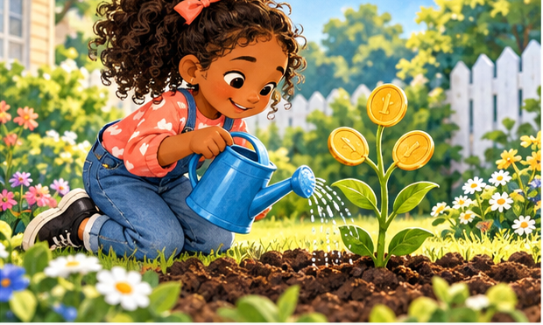
Talk about it: Why might leaving interest in the account help future savings?

Maya Saves for a Book
Maya wants a $12 book. She has $4 saved. She decides to save $2 each week from money her family has agreed she can earn.
After one week, she has $6. After two weeks, she has $8. After three weeks, she has $10. After four weeks, she has $12!
At the store, Maya checks the price with her grown-up. If sales tax applies, she will need a little more than $12. Her plan can change.
Maya is proud because she counted, waited, and reached her goal. A smaller goal would be worth celebrating, too.
Starting amount | Week 1 | Week 2 | Week 3 | Week 4
$4 | $6 | $8 | $10 | $12

Think it through: How much more did Maya need at the start? This story does not include interest.

Needs Wants and a Plan
A need is something important for health, safety, or daily life, such as food or a safe home. A want is something you would enjoy, such as an extra toy.
Sometimes the answer depends on the situation. Shoes may be a need. A second pair just because you like the color may be a want.
A budget is a plan for money. You decide what to spend, what to save, and what you may share.
Suppose you have $5 to plan with. You might save $3, spend $1, and share $1. Another plan might work better for you. Sharing is a choice, and kindness can also mean giving your time.
Buying something fun can be part of a good plan. The important step is thinking before spending.
Pretend plan: You have $10. Choose amounts for saving, spending, and sharing that add up to $10.

My Savings Goal
Choose a real or pretend goal. Draw it below. Ask a grown-up to help check the price, including any tax or other costs.
My goal is ______________________________
It costs $________. I already have $________.
I still need $________.
I plan to save $________ each week.
I will check my progress on _______________.
If my plan changes, I can make a new plan. Learning to save takes practice.
Draw your goal in the space below. Then draw four small stars and color one each time you make progress.

Play the Money Games
1. Coin clues: I am worth 5 cents. Jefferson is on my front. Which coin am I?
2. Coin count: You have 2 quarters, 1 dime, and 1 nickel. How many cents do you have?
3. Bill clues: I am on the $10 bill, and I was never president. Who am I?
4. Change game: A toy costs $4. You pay with $5. What change do you get? Ignore tax for this game.
5. Savings game: You have $6 and save $2 more. What is your new balance? Assume no fees or interest.
6. Same value: Which is worth more, 4 quarters or 1 one-dollar bill?
Bonus: Make $1 using two different kinds of coins. Explain your answer.
Play together: Make pretend price tags and take turns being a shopper and a cashier.

Words to Remember
Word | What it means
Money | Something people use to pay for goods and services.
Cash | Coins and bills.
Value | How much money something is worth.
Denomination | The value assigned to a coin or bill.
Save | Keep money to use later.
Savings account | An account for keeping money for later.
Deposit | Money put into an account.
Withdrawal | Money taken out of an account.
Balance | The amount of money in an account.
Interest | Extra money paid on some savings.
Budget | A plan for your money.
Goal | Something you work toward.

You are a money explorer now. Show someone one thing you learned!

For Parents and Teachers
Read aloud with younger children; invite older children to read the history pages and explain the money math. Use paper circles, classroom tokens, or supervised real coins. Keep small coins away from children who may put them in their mouths.
Try short lessons: identify a coin; make one dollar in different ways; play a shop game; choose a savings goal. Invite discussion about historical achievements and harmful actions without treating a portrait as an endorsement of every action.
Answers: Page 5: 5 cents. Page 6: 4 nickels. Page 7: dime. Page 8: 3 quarters. Page 9: 5 dimes. Page 10: 4 quarters. Page 12: Hamilton and Franklin. Page 14: 8 quarters. Page 15: $2. Page 16: 5 bills. Page 17: 4 bills. Page 18: $50. Page 19: 2 bills. Page 24: $7. Page 26: $8.
Page 29: 1. Nickel. 2. 65 cents. 3. Alexander Hamilton. 4. $1. 5. $8. 6. Equal. Bonus example: 2 quarters and 5 dimes.
Choose child accounts with care: check fees, opening and minimum balances, access rules, the current APY, adult ownership requirements, and insurance. Standard FDIC coverage is $250,000 per depositor, per insured bank, per ownership category. Savings insurance protects covered deposits if a bank fails; it does not cover every type of loss.
Stories and practice prices are classroom examples. Currency pictures come from the U.S. Mint and U.S. Currency Education Program. Coin photos are enlarged; bill images are reduced. The story scenes are imaginative illustrations.

Explore More
Official resources for grown-ups and curious readers. Facts checked October 5, 2026. Coin designs and account terms can change.
U.S. Currency Education Program - The Seven Denominations
https://www.uscurrency.gov/denominations
Bureau of Engraving and Printing - Currency FAQs
https://www.bep.gov/currency/faqs
U.S. Mint - Circulating Coins and their designs
https://www.usmint.gov/learn/coins-and-medals/circulating-coins
U.S. Mint - History of Presidents on Our Coins
https://www.usmint.gov/learn/history/historical-documents/history-of-presidents-on-our-coins
U.S. Mint - Dollar Coins
https://www.usmint.gov/learn/coins-and-medals/circulating-coins/dollar-coins
U.S. Mint - 2026 anniversary designs
https://www.usmint.gov/coins/coin-programs/semiquincentennial/
U.S. Mint - Penny FAQs
https://www.usmint.gov/news/media-kit/penny-faqs
FDIC - Money Smart for Young People
https://www.fdic.gov/consumer-resource-center/money-smart-young-people
NCUA - Share Insurance
https://mycreditunion.gov/protect-your-money/share-insurance
Image credits: U.S. Mint for coin photographs; U.S. Currency Education Program for bill images. Coin pictures show selected designs, and other designs remain in use. Bill illustrations are one-sided and reduced.
State and Nation
Learning about our world starts with asking good questions.

